Variable Compensation Model
June 2021
CEO and Executive Team

1. Objective of the Model
General Objective:
To drive long-term thinking in the Organization and to achieve alignment with the shareholder’s and other stakeholders’ interests, aiming at achieving short- and long-term goals, leading to the organization’s sustainability and fostering attraction and retention of the highest talent.

Specifics Objectives:
- Retribute the value generation, aligning the interests of the Executive team with the shareholder’s interests, aiming to achieve long term sustainability.
- Acknowledged and promote high performance of the Executive team according with the Bank strategy.
- Strengthen competitiveness in compensation to attract, motivate and retain the best talent.

2. Target audience

The Designation, Compensation and Development Committee its responsible of the selection process, according to the convenience and recommendation of the Presidency of the Bancolombia Organization

This model its applicable to the following positions:
- CEO
- Corporate Vice-presidents

3. General aspects
The Executives agreed and accepted that the variable remuneration it’s not salary therefore, it’s not considering to settle social benefit or severance payments.

4. Scheme

The scheme comprises two systems, one called Short Term with indicators to be defined on an annual basis, focused on the organization’s strategic achievements or challenges throughout the current year, and the second one is called Long Term which is based on compliance with indicators ensuring long-term sustainability, creation of value and alignment with shareholders’ interests.
4.1. Long term system
4.1.1. General aspects
- The bonus is calculated according to the compliance of indicators ensuring long-term sustainability, creation of value and alignment with shareholders’ interests.
- For the settlement of the bonus of each participant, the performance of the indicators established in this model is evaluated at the end of the evaluation period, the area responsible for each indicator provides the result to the Corporate Compensation and Incentives Management, and the corresponding compliance supports. to the Audit area who will oversee ensuring that the reported compliance is in accordance with what has been reported.
- Once the results are audited, the individual bonus of each participant is calculated for the measurement period.

4.1.2. Amount of the bonus and payment method
The maximum bonus amount per long-term incentive will be 2.8 monthly full salaries per year and will be pay 100% cash

4.1.3. Indicators and Objectives
- Four (4) indicators will be define for Bancolombia which are detailed below. The indicators themselves must be sufficiently challenging to allow this model to be self-sustainable. (View Annex 1)
- The objectives are defined annually for a 3-year period and must be relevant for the shareholders.
- Objectives could be modified by the Board of Directors only under extraordinary circumstances. (4.1.3.4)

4.1.3.1. Indicators
Indicator | Definition | Weight
Financial | ROE. It seeks to stimulate the improvement of the bank through mechanisms that guarantee the alignment of the interests of the employees with the interests of the shareholders. A return (ROE) that exceeds shareholder expectations is considered for this indicator | 35%
Share | Bancolombia share vrs. Peers Latinoamericanos. The measure considers the total return for shareholders of each of the banks in the sample and adjusts them for inflation.  The total real return of Bancolombia is then compared with the sample of the other banks to evaluate how well Bancolombia’s shareholders did with respect to the shareholders of the other banks.20273036 | 35%
Sustainability | DJSI. Companies uses DJSI and the fact of belonging to the index as a good management credential of having a long-term vision and a business model with a future. | 15%
Loyalty | Competitive NPS (NPS ©)  measures the intention of recommendation in our clients in relation to the selected competition in each market. It is a predictive indicator that allows us to anticipate and is obtained through an annual study that is done by geography, which gives us a ranking of NPS per business in each market. | 15%
Other relevant indicators | Financial strength  Metric related with promoting financial inclusion;  Metric related with building sustainability by participating in businesses with social purpose, climate commitment and financial well-being. | N/A

4.1.3.2. Objectives
- The objectives are defined by a 3-year period and the bonus will be pay only when the period end.
- Every year the objective will be defined for the following three years.
- The objectives could be modified only by the Board of Directors and under extraordinary circumstances.

SUMMARY OF THE LONG-TERM SCHEME:
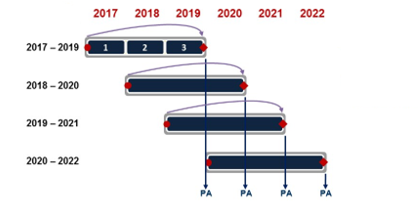
NOTE: Every year, the performance of each indicator and the compliance of the objectives will be evaluated by the Designation, Compensation and Development Committee.

4.2. SHORT TERM SCHEME
4.2.1. General aspects
The short-term model for executives it’s the same of the employees of the administrative department which is measure annually.
4.2.2. Amount of the bonus and payment method.
The maximum bonus amount per short-term incentive will be 4.2 monthly full salaries per year and will be pay 70% cash and 30% will be invest in an institutional Fund which invests exclusively in Bancolombia shares.

4.2.3. Indicators and Objectives
This model has two indicators:

- Value creation: The EVA, as a support of the variable compensation strategy it’s a management philosophy which directs the efforts of the company guaranteeing the best practices, adequate profitability and national and international competitiveness. This indicator seeks to stimulate the improvement of the organization through mechanisms that guarantee the alignment of the interests of the official with those of the shareholders. For the year 2021, the strategy is made up of the following indicators:
- Financial strength
- Metric related with promoting financial inclusion;
- Metric related with building sustainability by participating in businesses with social purpose, climate commitment and financial well-being.

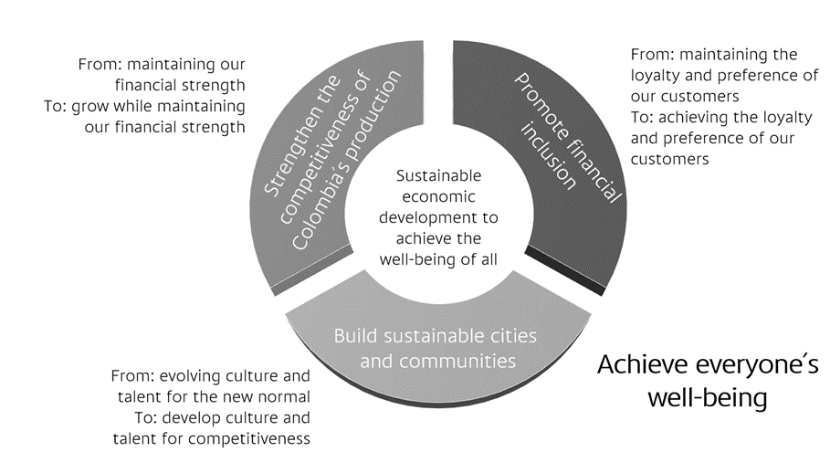

- Strategic Objectives: Strategic Planning with compliance and indicators that are measured over a period of 1 year

We are in a year where a rebound in the economy is expected, and although we will have significant challenges in the deterioration of our portfolio, we will be returning to the path of growth and profitability without neglecting credit risk by monitoring the past-due portfolio.

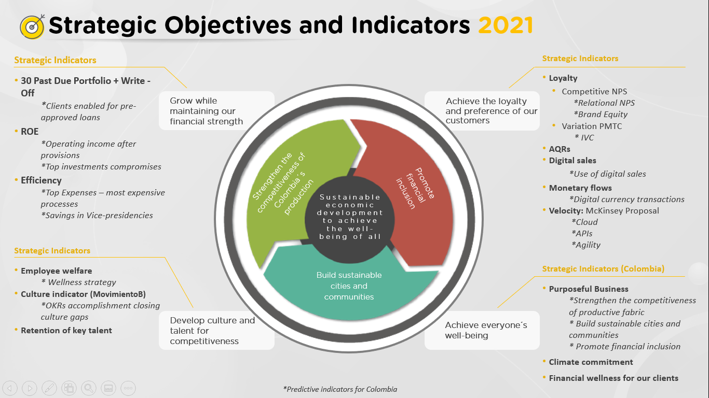
5. Rules

This model follows the same rules of the model for the administrative department.
5.1. Measure of results
The indicators that comply, partially or totally, with the established goals are subject to verification by the Audit area. Each one of those responsible for the indicators must keep the records, minutes and other information that adequately supports the result of the indicator.
5.2. Bonus settlement
This bonus will be considered liquidated once the financial statements have been approved at the general shareholders' meeting of the respective year and the compliance of strategic planning goals are certified.
5.3. Special cases
When any of the following cases are presented, the procedure will be as stipulated for each one of them. In the case that is not described in this policy, the procedure to be followed will be validated with the Corporate Human Resources Vice Presidency.
  - International Assignments: In the case where a participant is chosen for a long-term international assignment process, the bonus is calculated according to the salary conditions of the country of origin and the payment will be made in accordance with the terms of the assignment.
  - Replacements: When a non-participating employee of this long-term bonus scheme oversees a participating position, he or she is not eligible to participate in it.
  - Withdrawal, mutual agreement or dismissal of the participant before the end of the participation period: In the event that the participant stops providing their services to the company before the end of the participation period, there will be no payment
  - Old-age pension or deferred bonus before the official liquidation of the system: In the case of old age pension or deferred bonus before the end of the measurement period, the indicators will be considered fulfilled and the bonus will be paid proportionally to the time worked during it.
  - Pension for disability or death of the participant before the official liquidation of the system: In case of pension for disability or death of the participant before the end of the measurement period, the indicators will be considered fulfilled and the bonus of the same period will be paid to the 100%
  - Transfer to other companies of the Group where this scheme exists before the end of the evaluation period: In case of transfer to a company of the Group, the collaborator will participate with the indicators of the company to which it arrives and this company will assume the payment.
  - Creation of a position, internal promotion or hiring of a new collaborator in the participating levels during the evaluation period: In the case of the creation of a position, internal promotion or hiring of a new collaborator at the levels of the structure that participate of this system, the payment is settled proportionally to the time it has been performed.
  - Employees participating in a license: If a participant of the system is on unpaid leave, in the measurement period, for more than a third, the bonus will be paid proportionally to the time he / she is active.

ANNEX 1.
LONG TERM SCHEME
INDICATORS
- Introduction
The long-term scheme its define by 4 indicators that will be explained below:
Indicator | Definition | Weight
Financial | ROE | 35%
Related with the share | Bancolombia share vs. Latin-Americans Peers. | 35%
Sustainability | Dow Jones Sustainability Index (DJSI) | 15%
Loyalty | Competitive NPS (NPS©) | 15%

- Indicator 1: ROE

  - How this indicator is measure

This remuneration is based on terms of return on investment (ROE):

Profitability that exceeds the expectations of the investor

Formula: Annual Accumulated Net Income / Equity

- The current capital cost will be taken at the close for the Group that corresponds to Colombia (Colombian pesos).
- The ROE will be calculated on the average accounting equity of the last two years of the triennium
- The capital cost of each closure will be taken to analyze the follow-up

The ROE goal will be defined according to the performance of the Bancolombia Group. The time horizon is defined in a mobile way for three years, for example, the 2021 target will be calculated based on the ROE of the last three years (2020, 2019 and 2018) and so on.

To achieve the desired profitability result, the long-term goal will be calculated by the financial control management of the Vice Presidency of Strategy and Finance. For its construction, the macroeconomic scenario estimated by Bancolombia's Economic Research (for Colombia), financial forecasts of each of the group's subsidiaries and the guidelines of financial objectives based on indicators such as: return on equity, financial efficiency, cost will be considering of credit and portfolio coverage.

- Indicator 2: Bancolombia share Vs. Latin-Americans Peers

This indicator considers the total return in original currency for the shareholders of each of the banks that make up the sample; the return is measured over a period of three years, corresponding to the three-year period of measurement of the targets and is adjusted with the inflation corresponding to the country of origin of each of the entities evaluated.

Subsequently, the return in real terms of Bancolombia's preferential share is compared with that of the other banks in the sample and it is evaluated how well Bancolombia's shareholders did with respect to the shareholders of other comparable banks in the region.

This comparison its useful to evaluate how well the bank's management has been interpreted by its shareholders and the market, comparing it relatively with the management market interpretation of the other Latin American banks.

  - How it this indicator measure
Real total return = (fp + Dividends)/(ip*(1+inflation)):
ip = (initial price)
fp = (final price)
Dividends
Inflation

  - What is considered to measure this indicator

To calculate the actual total return of each bank, the following data are used:
Variation of prices in the analysis period plus dividends delivered by the bank for the same evaluation period.
Inflation during the evaluation period in the country of origin of each of the banks.

  - Why it is important this indicator.

By making part of the remuneration referenced to the return of the shareholder, the interests of the CEO and the corporate vice-presidents align with the interests of the shareholders, avoiding potential agency problems.

  - Banks sample.

16 banks will be considered and the reasons for choosing them are the following
- It is a representative sample.
- Being a representative sample, the effect of isolated date or “outlayers” can be minimized for a certain period.
- All Banks are from comparable countries in the region, so they are exposed to similar macroeconomic risks.
- They are Banks with that have a wide range of similar products.
- The sizes of the Banks of the sample are similar. (Except of Brazilian Banks).
- All this Banks are listed on stock exchanges, which requires transparency.

  - Objective

At the end of the measurement periods, we will divide the sample into quartiles. It will depend on the location of the Bancolombia Group's result in this quartile. (This goal will be set by the Designation, Compensation and Development Committee at the beginning of each quarter)

- Indicator 3: Sustainability Indicator- “DJSI”

The Dow Jones Global Sustainability Index is a worldwide indicator that measures the sustainable performance of companies in economic, social and environmental matters. More than 2,500 companies listed on international exchanges, from approximately 45 countries, in around 59 sectors of the economy are evaluated, of which only the best 10% of them are included in the index with an investment ceiling by sector of 15% of the stock market capitalization.

  - Objective

The Compliance of this indicator will depend on the category in which Bancolombia is located at the end of the measurement period. This goal will be defined at the beginning of each triennium by the Designation, Compensation and Development Committee of the Bancolombia Group

- INDICATOR 4. COMPETITIVE NPS

Competitive NPS measures the intention of recommendation in our clients in relation to the selected competition in each market. It is a predictive indicator that allows us to anticipate and is obtained through an annual study that is done by geography, which gives us a ranking of NPS per business in each market.

- Compliance:

The final fulfillment of the long-term Variable Compensation scheme will be the result of multiplying the final compliance of each indicator by the weighted weight. The final fulfillment will estimate the bonus, below an example:

Indicator | Weight | Compliance | Weight x Compliance
Indicator 1: SVA | 45% | 100% | 35%
Indicator 2: Share | 45% | 100% | 35%
Indicator 3: DJSI | 15% | 100% | 15%
Indicator 4: Loyalty | 15% | 80% | 12%
Compliance |  |  | 117%

- Compensation Board:
This is the compensation Board for this scheme:
Compliances | Salaries
120% | 2.80
50% | 0

ANNEX 2.
SHORT TERM SCHEME
INDICATORS, OBJECTIVE AND STRATEGIC OBJECTIVES.

- Indicators and Objectives

  - Defined model

The short-term model is formed by the value creation and the strategic Board as follows:

Annual Bonus
4.2 salaries = [ Value creation (Sum of SVA)] Strategic Objectives
3.5 Salaries

3.78 would be the maximum remuneration in shares that the Senior Management Team would achieve in a period of 3 years.

The formula would be the following:
4.2 integral salaries x 30% received in shares = 1.26 times the base salary
1.26 the base salary that for 3 years would correspond to 3.78

1.2. SVA
This indicator is measure in the following terms

Sum of Value creation =
SVA Colombia +/- SVA Banistmo +/-SVA Banco Agricola +/- SVA BAM – (goodwill/20)

1.3. Strategic Objectives:
The strategic goals, is the short-term orientation guided by the managers of the organization to fulfill the mission and vision of the Group
These goals have the function of Voucher Moderator by SVA because it amplifies or decreases the bonus depending on the execution of the goals. These goals will be evaluated at the annual cut.

The ranges of fulfillment of the goals must range between 50% as a minimum value and 120% as a maximum, this means that each employee may increase by 20% or decrease by 50% their bonus generated by the SVA.

The weight of each map is defined as follows:

Corporate Board Vice-presidency Board

CEO 100%
Corporate Vice-presidents 70% 30%

Compliance: The final fulfillment of the short-term strategic goals will be the result of multiplying the final compliance of each indicator by the weighted weight.

